ENC (SEAL) Ret. Roger W. Roberts
rroberts@SEALFit4Life.com

When you learn the Exercise Mechanics, you will make your exercises
easier, and immediately increase your repetitions, speed, and strength.
Exercise Mechanics
K.I.S.S. - Keep It Super Simple - Fitness

EXERCISE MACHANICS

" SPEED KILLS... "

"SLOW IS SMOOTH & SMOOTH IS FAST"

NEVER SACRIFICE TECHNIQUE FOR SPEED FOR A TEST OR DURING A WORKOUT, SPEED KILLS GOOD TECHNIQUE.

MYTH: "IF YOU GO AS FAST AS YOU CAN ON A TIMED FITNESS TEST, LIKE PUSH-UP OR SIT-UPS, YOU WILL DO MORE REPS."
- QUESTION: THEN WHY DON'T YOU START A 3 MILE RACE AS FAST AS YOU CAN TO COVER MORE MILEAGE FASTER?
- ANSWER: BECAUSE YOU WILL FOCUS ON SPEED INSTEAD OF GOOD TECHNIQUE AND BURN YOURSELF OUT FASTER.

TRUTH: IF YOU FOCUS ON TECHNIQUE AND DO FULL RANGE OF MOTION YOU WILL HAVE EVERY REP COUNT FOR A FITNESS TEST AND HAVE FASTER, BETTER WORKOUTS.

STRENGTH VS POWER

STRENGTH - IS WHAT MOST EVERYONE USES FOR PUSH-UPS, SIT-UPS AND PULL-UPS DURING A FITNESS TEST OR WORKOUTS. WHEN SOMEONE IS USING STRENGTH ONLY, THEY MOVE THROUGH THE EXERCISE AT A SLOW SPEED.

POWER - IS WHEN YOU TRUST OR USE AN INITIAL BURST OF ENERGY TO START THE MOVEMENT. THIS EFFORT WILL HELP YOU TO CREATE THE FORCE NEEDED TO MINIMIZE THE ENERGY NEEDED TO PERFORM AN EXERCISE.

EXERCISE MECHANICS

for
PUSHUPS ~ PULLUPS ~ SITUPS ~ SWIMMING ~ RUNNING

PUSH-UP MECHANICS

"CATCH AND THRUST"
This technique comes from a clapping push-up. Performing clapping push-ups will instill in you the proper technique for push-ups. When you do clapping push-ups, you thrust up off the ground, clap and catch yourself at the bottom of the push-up.
STEPS:
- Do 3 - 5 clapping push-ups * notice how hard you have to trust up to do a clap with the push-up
  - After you clap, notice that you "catch" yourself at the bottom of the push-up.
  - To do the next clapping push-up, you have to "thrust" up
- Do 3 - 5 clapping push-ups without the clap
  - From the up / starting push-up position, drop to the bottom or "catch" position
  - Thrust up by exploding upward, the same as you did for the clapping push-up, but without leaving the floor with your hands, then
THOUGHT PROCESS:
- \\\ Thrust and catch \\\
- From the top/starting position of the push-up. Drop to the catch (bottom) and then thrust up to the top, straight arm locked position. Note: slightly roll back on your heels to lock out at the top.
- Repeat
- Focus on doing 1 repetition / 2 seconds.

THe VIDEObelow WILL TEACH YOU THE BEST TECHNIQUE TO USE FOR PUSH-UPS. IT WILL instantly increase your repetitions, and if you joi the military, it will KEEP YOU FROM BECOMING A TARGET IN BOOTCAMP.

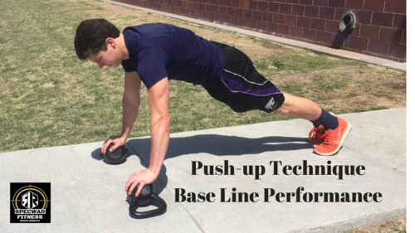

Base Line Performance Push-up Video
Learn the technique and science for the Push-up

- Click on the video - https://youtu.be/VgXD7r8Hjos

PULL-UP MECHANICS

" INGAGE AND THRUST "

STEPS:
7 Quick steps to mastering the pull-up.
- Point your toes
- Contract your ABs
- Engage the shoulders
- Contract the Scapula (Center Upper Back)
- Thrust up to the bar (Look forward NOT up to the bar)
  - Elbows - pull outward
  - Elbows - Pull back at top of pull-up
  - Pull chin over bar
- Drop down with control at the bottom
- Pause with shoulders engaged and arms straight
Repeat
Description:
Most people do pull-ups with a relaxed body. This will cause you to possibly swing or kip during the pull-up. You must practice these steps with every pull-up workout. DO NOT focus on speed or repetitions. Pause between each rep and re-engage both physically and mentally. Do each rep as perfect as you can. Grip the bar, engage shoulders by trying to pull your shoulder blades together. Contract the Scapula (Upper, Middle back), point the toes and contract the Abs. These steps should accrue as one step once you master the technique. Now thrust up to the bar by moving the elbows outward while looking forward. Do not look up at the bar, this will cause you to "chicken neck" or bob the head. Once you have your chin over the bar, pull your elbows back to get higher on the bar. PAUSE. Go a controlled drop back to the dead hang. Catch yourself at the bottom, or slow down so you do not snap or hyper extend the elbows. PAUSE. REPEAT.
This video will teach you how to acquire your maximum power and form to reach your full potential doing pull-ups. (No more kipping or half pull-ups)

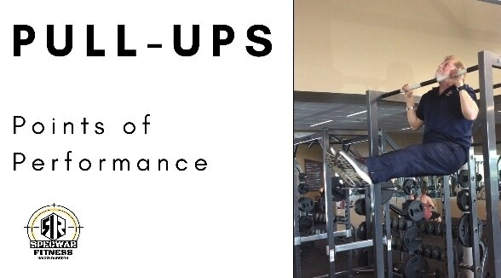

Pull-up Technique Video
Click on Video

Pull-ups Points of Performance

This video will teach you how to get higher over the bar and never kip or swing again.

- Click on the Video -

BEHIND THE NECK LAT PULL TECHNIQUE

Follow the tips for the Behind the Neck Lat Pulls and you will increase your pull-ups and avoid shoulder injuries.

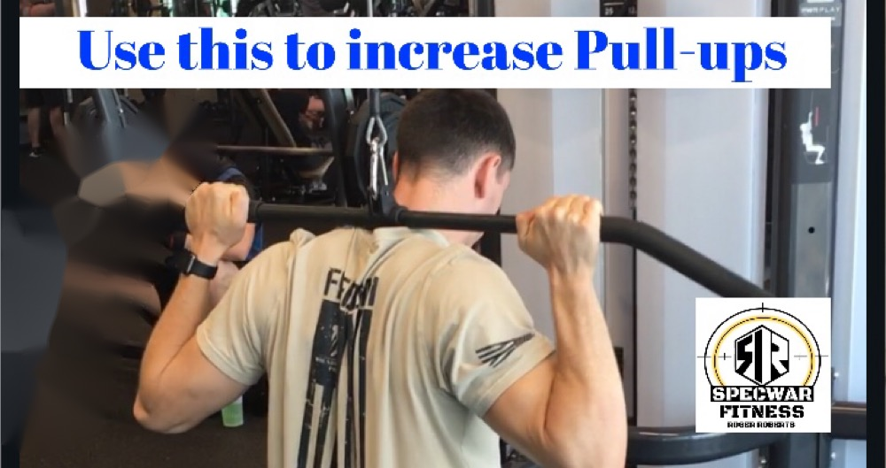
Behind the Neck Lat Pull Techniques

SIT-UP MECHANICS - “Thrust, Relax, Fall "

Most people will stay tense or stay contracted in the ABs throughout the entire movement. This will fatigue your ABS quicker than if you learn to relax during the movement. So, you must learn how to start with Power or a thrust and when to relax.
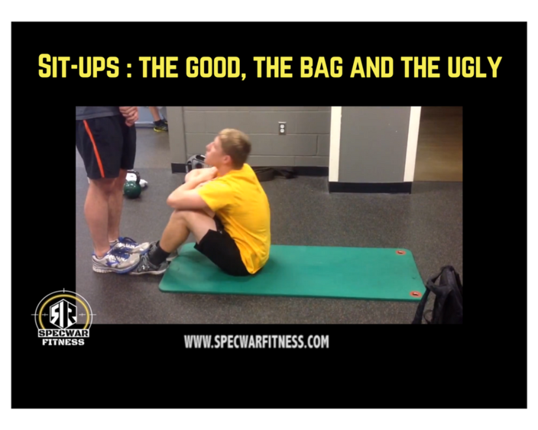

DRILLS:
- Lay flat on your back, bent knee, hold hands perpendicular up over your chest. Secure feet under object or have someone hold them for you. Do 5 sit-ups with head in a natural position.
- Do the same drill with hands crossed over shoulders.
- Do a sit-up by trusting up to the top of the knees and have your partner grab and hold your elbows.
  - With your partner holding your elbows, totally relax and have your partner release your elbows, you should fall or roll back with your ABS totally relaxed. Repeat 3 - 5 times.
- Do 5 reps by thrusting up and after the initial trust, start to relax the ABs and use your momentum, tough the knees, and relax and roll back to the floor with you head on the deck.

WATCH THIS VIEDO AND LEARN THE RIGHT WAY TO DO SIT-UPS AND LEARN WHAT NOT TO DO WHEN DOING YOUR SIT-UPS.

Sit-ups Points of Performance

These techniques will help you perform the sit-up correctly and increase your reps.

- Click on the Video - https://youtu.be/H89MLf56YR0

RUNNING MECHANICS - “Relax and focus"

Most runners are too tense when they run. By applying these running techniques, you will learn to stay relaxed, focused, and able to analyze your stride, PRMs, breathing cadence and posture to run at your maximum efficiency.

Key points:
- Have a slight forward lean
- Ball to Toe foot strike
- Breath primarily through your mouth
- Breath with a cadence
- Focus on exhaling as deep as you can
- Relax your shoulders
- Have a relaxed swing in the arms
- Relax your Quads (Thighs) as you step forward
- Give a slight pull with your toes when your feet make contact with the ground
- Pick a focal point 5 yards in front of you as you run

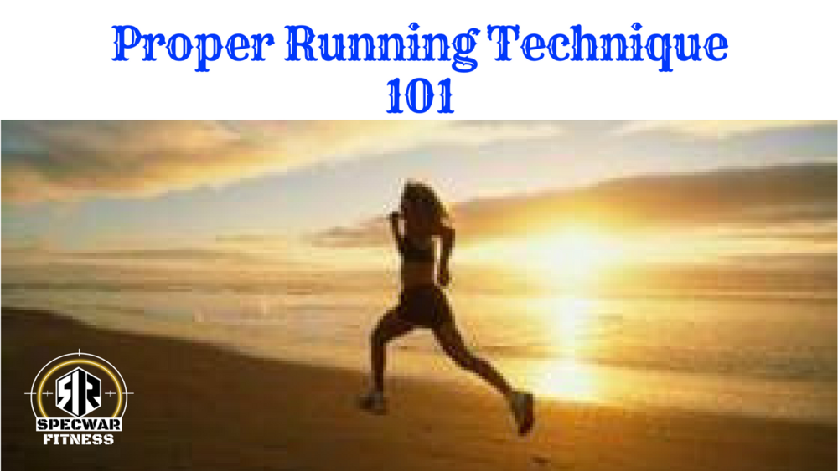

Proper Running Techniques 101

Learn these running techniques and run faster and more relaxed and efficient.

- Click on the video - https://www.youtube.com/watch?v=NVJcYOpHHzI&t=430s

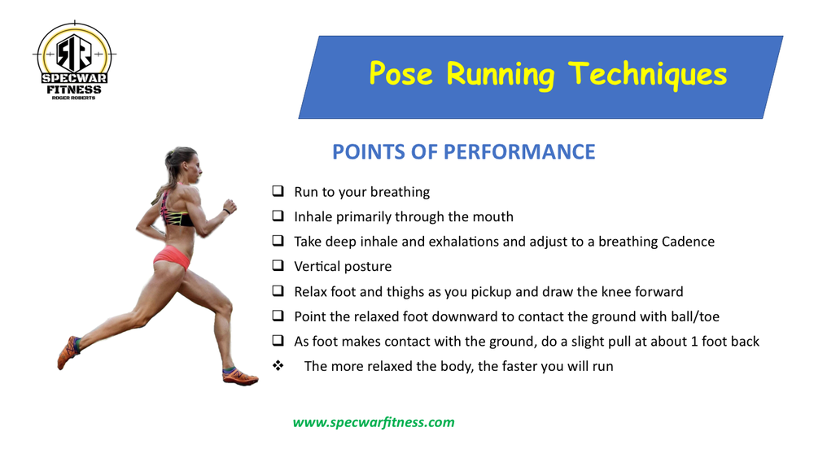
This running technique is the most common in the running world for speed

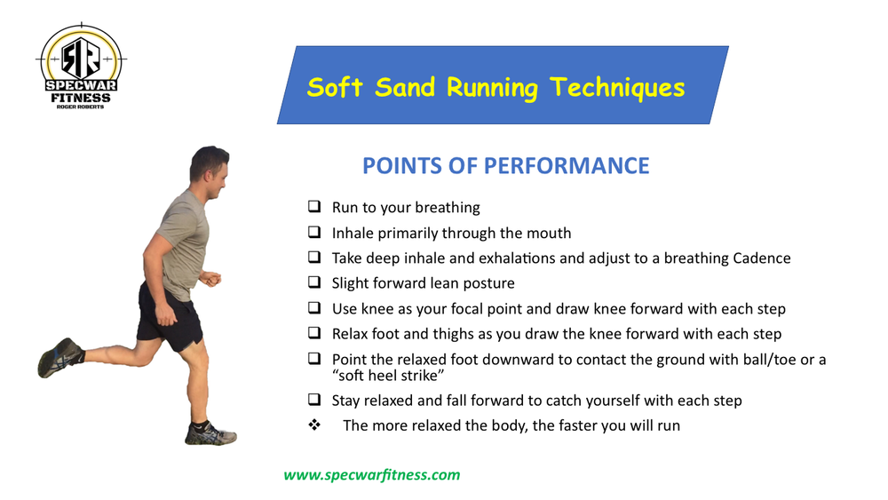
This Technique is used for soft sand running on the beach

SWIMMING MECHANICS - “Relax, Float, Reach and Glide"

Most untrained swimmers are too tense when they swim, they try to muscle it through the water. Do not fight the water, the water will always win. By applying these swimming techniques, you will learn to stay relaxed, balanced, elongate (REACH). Have a slower relaxed breathing rhythm to swim at your maximum efficiency.

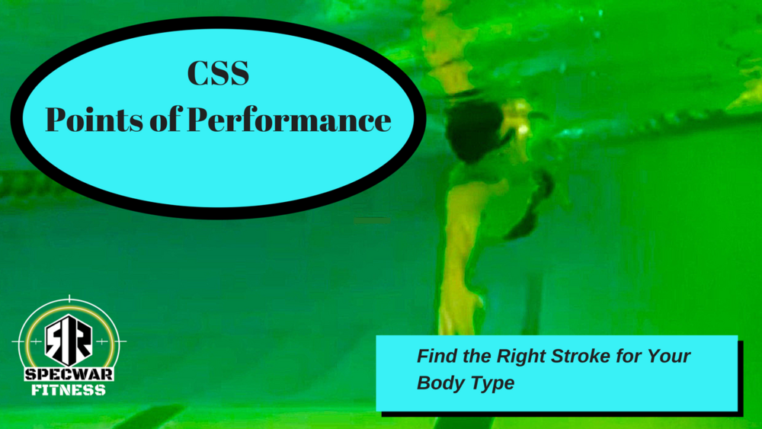

Combat Sidestroke Points of Performance

This video will show you various techniques that you can try and see which ones work best for you.

- Click on video - https://youtu.be/IDBy57yjX3Y

BAD Techniques - PST

Now that you know how to do the proper techniques, have a look at what bad techniques look like during a PST. I tried to make a video with my trainees for a bad techniques video but I could not find a trainee who could do the bad techniques for the video because they have re-programed their minds and body with the proper techniques. It will take approximately two weeks to re-program your movement patterns.

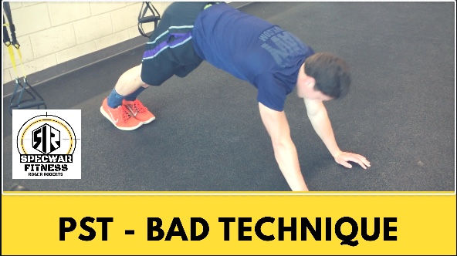

Sample of a bad PST

Here you will see the incorrect performance of exercises. If you are making these mistakes, make corrections now.

- Click on the video - https://youtu.be/C146d8Cprlo

